**DBMS LAB 1**

**PROGRAM 1: INSURANCE DATABASE**

Consider the insurance database given below. The primary keys are underlined and the data types are specified.

PERSON (driver-id#: string, name: string, address: string)

CAR (Regno#: string, model: string, year: int)

ACCIDENT (report-number: int, date: date, location: string)

OWNS (driver-id#: string, Regno: string)

PARTICIPATED (driver-id: string, Regno: string, report-number: int, damage-amount: int)

* 1. Create the above tables by properly specifying the primary keys and the foreign keys

**create table PERSON**

**(**

**Driver_id varchar(60),**

**Name varchar(60),**

**Address varchar(80),**

**primary key(Driver_id)**

**);**

**create table CAR**

**(**

**Regno varchar(60),**

**Model varchar(20),**

**Year int,**

**primary key(Regno)**

**);**

**create table ACCIDENT**

**(**

**Report_number int,**

**Date date,**

**Location varchar(80),**

**primary key(Report_number)**

**);**

**create table OWNS**

**(**

**Driver_id varchar(60),**

**Regno varchar(60),**

**primary key(Driver_id,Regno),**

**foreign key(Driver_id) references PERSON(Driver_id),**

**foreign key(Regno) references CAR(Regno)**

**);**

**create table PARTICIPATED**

**(**

**Driver_id varchar(60),**

**Regno varchar(60),**

**Report_number int,**

**Damage_amount int,**

**primary key(Driver_id,Regno,Report_number),**

**foreign key(Driver_id) references PERSON(Driver_id),**

**foreign key(Regno) references CAR(Regno),**

**foreign key(Report_number) references ACCIDENT(Report_number)**

**);**

* 1. Enter at least 5 tuples for each relation.

**insert into PERSON(Driver_id,Name,Address) values('P1','Akshay','NR COLONY'),**

**('P2','Jyoti','JAYANAGAR'),**

**('P3','Radha','TYAGRAJNAGAR'),**

**('P5','Rajat','BANASANKARI'),**

**('P6','Jatin','BASVANGUDI');**

**insert into CAR(Regno, Model, Year) values('KA056TB','BMW',2019),**

**('KA456BT','SUZUKI',2001),**

**('KA467BT','HYUNDAI',2003),**

**('KA098BT','MAHINDRA SCORPIO',2009),**

**('KA648BT','TATA ALTROZ',2007);**

**insert into ACCIDENT(Report_number,Date,Location) values(096,'2020-04-14','MG ROAD'),**

**(045,'2009-07-28','DHARWAD'),**

**(235,'2003-07-22','HUBLI'),**

**(123,'2010-03-22','BASVANGUDI'),**

**(453,'2010-09-21','JAYANAGAR');**

**insert into OWNS(Driver_id,Regno) values('P1','KA456BT'),**

**('P6','KA467BT'),**

**('P5','KA467BT'),**

**('P3','KA098BT'),**

**('P2','KA648BT');**

**insert into PARTICIPATED(Driver_id,Regno,Report_number,Damage_amount) values('P1','KA456BT',045,5000),**

**('P6','KA467BT',235,8900),**

**('P5','KA467BT',123,4000),**

**('P3','KA098BT',453,6500),**

**('P2','KA648BT',096,1200);**

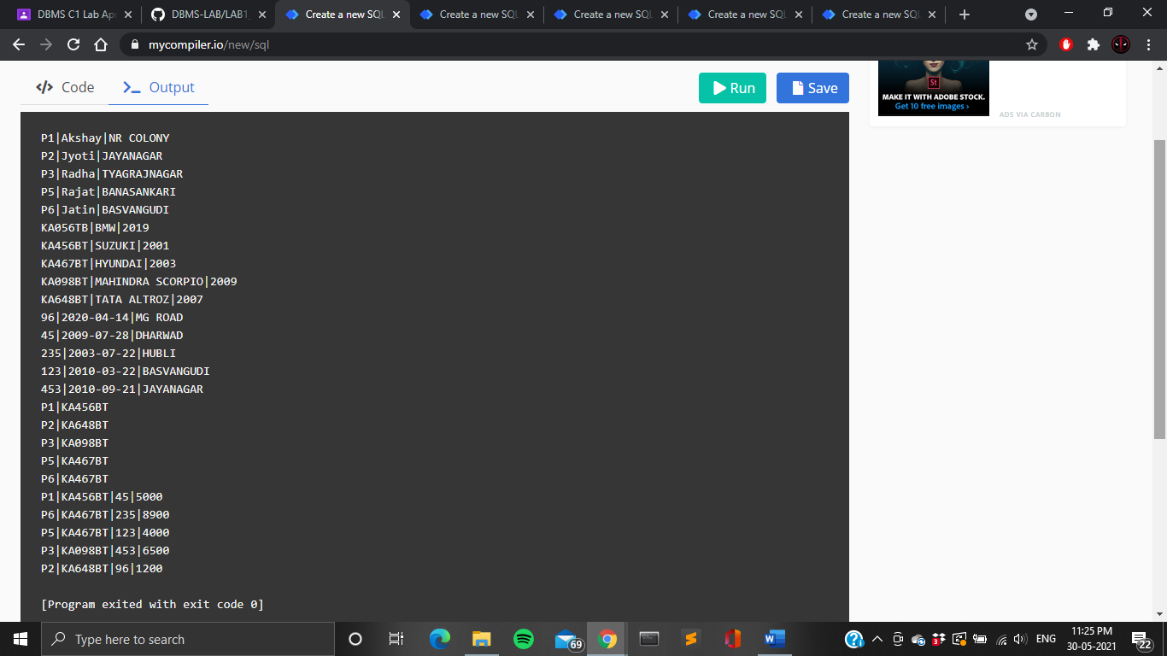









* 1. Demonstrate how you
     1. Update the damage amount for the car with a specific Regno in the accident with report number 12 to 25000.

**update PARTICIPATED set Damage_amount=25000 where Report_number=235 and Regno='KA467BT';**

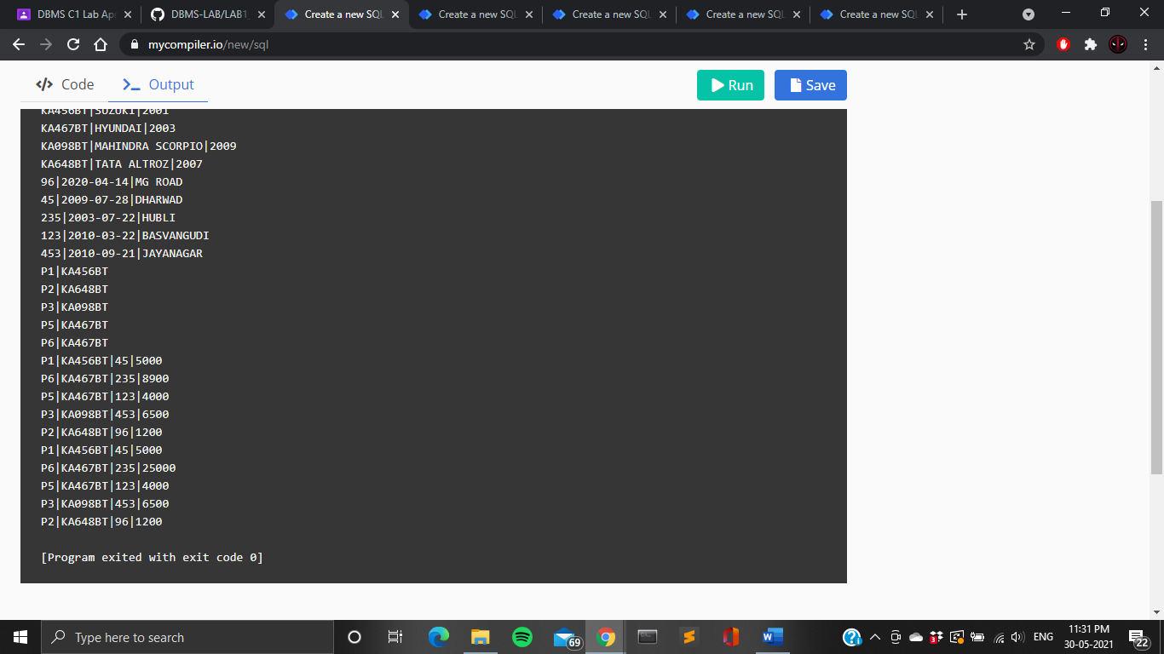

* + 1. Add a new accident to the database.

**insert into ACCIDENT values(002,'2021-02-12','Jalahalli');**

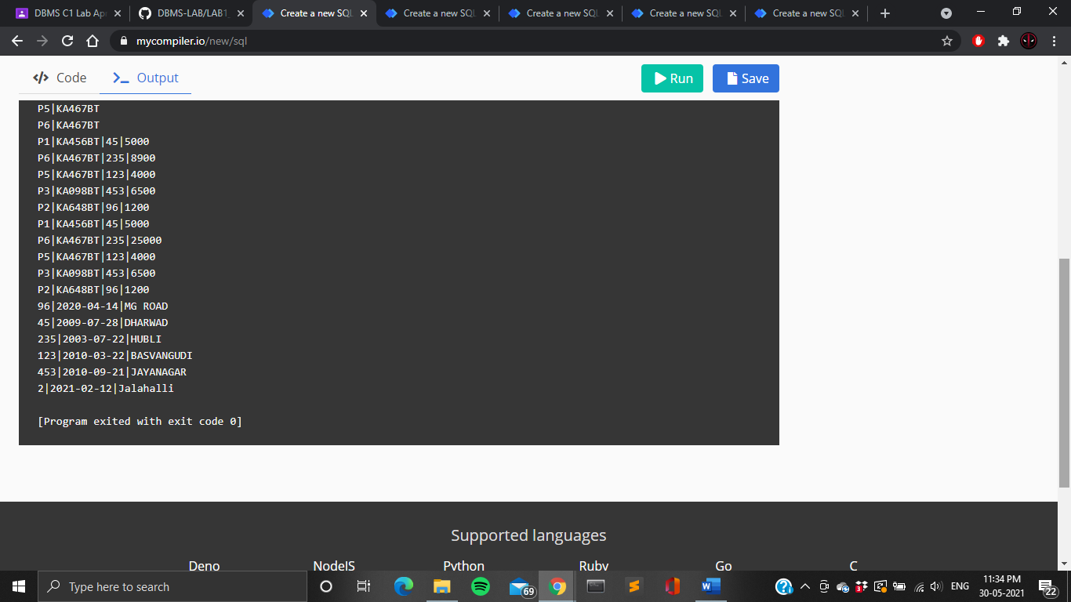

* 1. Find the total number of people who owned cars that involved in accidents in 2008.

**select count(*) from ACCIDENT where date between '2010-01-01' and '2010-12-31';**

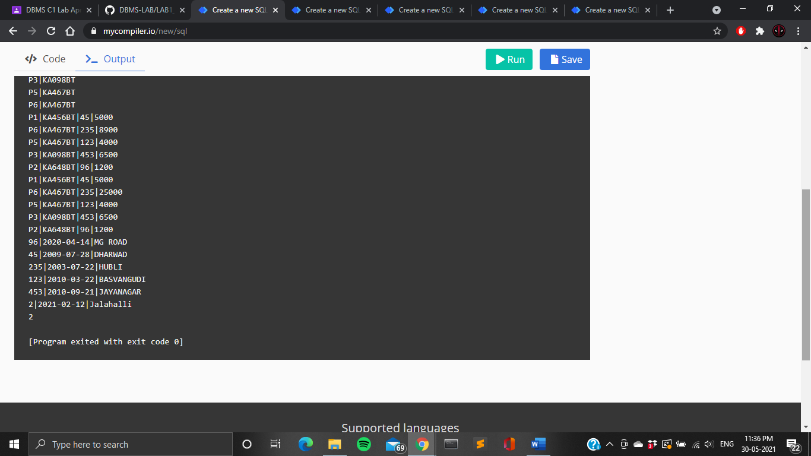

* 1. Find the number of accidents in which cars belonging to a specific model were involved.

**select count(*) from PARTICIPATED join CAR on CAR.Regno=PARTICIPATED.Regno where CAR.Model="TATA ALTROZ";**

